**PRACTICAL-1**

# ****STUDY OF SOFTWARE AND HARDWARE REQUIREMENTS OF DIFFERENT OPERATING SYSTEMS****

**Operating System Choices and Issues**

The *operating system* (commonly abbreviated *OS*) is the central piece of software that acts as the "general manager" of the PC, interfacing the hardware of the system and the applications that you want to run. Every PC has to have an operating system in order to allow it to do anything useful. Some PCs actually have more than one.

I'm not going to try to explain all there is to know about operating systems in a few paragraphs. Aside from being pointless--it can't be done in a quality manner--it is beyond the scope of this Buyer's Guide. I do, however, want to introduce the more common PC operating systems, and more importantly, discuss how the choice of software and operating system affects your hardware selections.

Most PCs run one of the Microsoft operating systems. These are broken into two general categories:

* **"Consumer" Operating Systems:** These are operating systems designed primarily for use by individuals: Windows 95, Windows 98 and Windows ME (Millennium Edition). They evolved from the older Microsoft operating systems (DOS and Windows 3.1). Windows ME is the newest in this line and is an enhanced version of Windows 98, which is in turn very similar to Windows 95, but updated. These are the most widely used operating systems in the PC world, and they support the widest range of hardware and software, but are susceptible to crashes and may have performance issues. (Incidentally, there are many machines still running Windows 3.1 or even straight DOS!)
* **"Professional" Operating Systems:** Windows NT, and its successor, Windows 2000, were redesigned from the ground up rather than being based upon older versions of DOS or Windows. They are focused towards the professional and business market, and emphasize security, reliability and performance. Their disadvantages are software support, hardware requirements, and cost. There are several different versions of each of these, depending on how much capability you need and how much you are willing to spend.

Most new PCs are now shipping with Windows 98, Windows ME or some level of Windows 2000. However, if you don't want to go with a Microsoft operating system, there are alternatives. One is an increasingly-popular version of UNIX called *Linux*; another is *BeOS*. Most people stay with Windows and don't consider these choices because they want to stay with the "mainstream" and be able to run Windows applications. Linux and BeOS certainly don't run nearly as much software as the various Windows versions do, but they support a reasonable selection of applications in their own right. If properly set up, they can also run much more reliably and with higher performance than the Microsoft operating systems. They are usually more complex to install and require more skill to manage than the mainstream OSes. As I'll discuss below, they also may require you to do your own technical support for them.

The operating system sits between the hardware of the system and the applications. This means that there are two different compatibility issues that must be taken into consideration when planning your system: the applications you want to run must be compatible with the operating system, and the hardware must be compatible with the operating system as well. Here are some of the critical issues to keep in mind regarding operating system choice and your new PC:

* **Special Application Compatibility:** Not all applications will run on all operating systems. If you have a special application that is the primary reason for purchasing the machine, you should let that guide your operating system decision: it may require a particular OS. For example, some high-end applications will only run on Windows NT or Windows 2000. Some may only run on Windows 95, 98 or ME. Some require Linux or even a different flavor of UNIX.
* **General Application Compatibility:** Some operating systems support a wider variety of software applications than others. Microsoft is trying to get all new Windows software to be written so that it will run on both the "consumer" and "professional" operating systems, and most applications do work on both. There are, however, software programs that only work on the consumer operating systems. This is especially true of older software, and also of many entertainment software titles--these often have issues with Windows NT or Windows 2000.

**Note:** Utility software is always OS-specific to some extent since it is working with the OS at an intimate level. Utility software writers usually make different versions for different operating systems.

* **Hardware Compatibility:** You need to ensure that the operating system you want to run will work with the hardware you are selecting, and vice-versa. Some PC manufacturers will not support some operating systems--in fact, the hardware may still work with an "unsupported" OS, but the company may not provide technical assistance. Be especially careful with notebook machines, which may not function properly at all if you install operating systems on them that haven't been tested and approved.

**Warning:** Many hardware vendors will not provide support for non-Microsoft operating systems for a simple reason: they probably don't have anyone around that knows anything about them, making support nearly impossible. If you want to use one of these you'll have to rely on your own smarts in combination with a healthy assortment of online resources. If you install Linux on a standard retail PC and run into any problems with the hardware, *expect* the company to blame it on the Linux install, even when it is clearly a hardware issue..

* **Specific Hardware and Driver Support:** On certain operating systems your PC may work, but certain hardware items may not function. This is usually either because no drivers have been written for them, or the operating system is incapable of making use of the hardware. For example, Windows 95 and 98 will not make use of more than one system processor in a PC, but Windows NT and 2000 will use two, four or more CPUs. Windows NT and 2000 of course have other restrictions that the consumer operating systems don't. Sometimes an operating system can have support added for newer hardware through a patch.
* **Hardware Requirements:** Some operating systems are much more demanding when it comes to the hardware needed to run them than others. In general, the newer the operating system, the more CPU power and system memory it needs to run effectively. It's also generally the case that the professional operating systems require more hardware than the consumer-level ones do, especially system memory.

You may be given a choice at the time you order your PC of which operating system you prefer, and also if you want it preinstalled or not. Having the OS preinstalled is more convenient and will save time over doing it yourself, but many "power users" prefer to install the operating system themselves so they have control over the various choices made during the install process. Most companies will install the operating system by default, so if you don't want them to, be sure to ask.

UNIX

**HARDWARE REQUIREMENTS:-**

* 80 MB hard disk
* 40MB  is used by actual UNIX OS files
  + 10-20MB is used as swap space
* 4 MB of RAM on a 16-bit microprocessor(80286,or preferably 80386/80486)
* 4/8/16 port controller card;-These are used to connect the terminals to the host machine.

SOFTWARE REQUIREMENTS:-

STARTUP

On starting our system we have to place a login and password. The password will appear in encrypted form. If any of these is wrong then we will not be able to login and for the security measures, the system does not tell which one is incorrect. We usually get three to five attempts to get it right.

  LINUX

**HARDWARE REQUIREMENTS:-**

* 1.8GB hard disk
* The Red Hat Linux installation defaults  to a standard US English 105 key keyboard
* Red Hat Linux supports two-button and three-button mice, as well as wheel mice.
* Network card: - During the installation, Red Hat Linux tries to detect the network installation card (NIC) and load the appropriate software driver automatically. One should note the name of the chipset of the NIC in advance of installation, just in case installation process fails to determine it.
* Sound card and Video card:- While the installation tries to detect the sound card or video card ,it sometimes doesn’t succeed . Therefore, it’s good to note the name of the sound card and the video card chipset.

SOFTWARE REQUIREMENTS:-

STARTUP

On starting our system we have to place a login and password. The password will appear in encrypted form. If any of these is wrong then we will not be able to login and for the security measures, the system does not tell which one is incorrect. We usually get three to five attempts to get it right.

WINDOWS XP

HARDWARE REQUIREMENTS:-

* Speakers or headphones
* Sound card
* Video adapter and monitor with Super VGA (800 x 600)or higher resolution
* Keyboard and a Microsoft Mouse or some other compatible pointing device
* CD-ROM or DVD-ROM drive
* At least 1.5 gigabytes (GB) of available space on the hard disk
* At least 64 megabytes (MB) of RAM (128 MB is recommended)
* Pentium 233-megahertz (MHz) processor or faster (300 MHz is recommended)

**SOFTWARE REQUIREMENTS:-**

STARTUP

On starting our system we place a password to it for security. So unauthorized users can’t access the system. This will prevent illegal operation and provide security.

BOOT SETUP

For CMOS setup we place a password to it. For that registration is used so that no one can change the Configuration at our system and create problem. Thus our OS is secure.

DOS

(Disk Operating System)

HARDWARE REQUIREMENTS:-

* MS-DOS 3.3 or later - IBM SGA or SVGA graphics adapter
* IBM-PC or IBM-AT compatible personal computer - 640 Kb memory available
* A math coprocessor (INTEL 8087) - A floppy drive, either 3.5" or 5 1/4"

Optional:

* IBM PS/2 or compatible
* Hard disk (10 Mb or more)
* Printer

Add Windows 7 and Windows 8….

Practical 2 theory part…

**Disk Allocation Methods**

a) Contiguous allocation

* each file occupies a set of consecutive addresses on disk
* each directory entry contains:
  + file name
  + starting address of the first block
  + block address = sector id (e.g., block = 4K)
  + length in blocks
* usual dynamic storage allocation problem
  + use first fit, best fit, or worst fit algorithms to manage storage
* if the file can increase in size, either
  + leave no extra space, and copy the file elsewhere if it expands
  + leave extra space

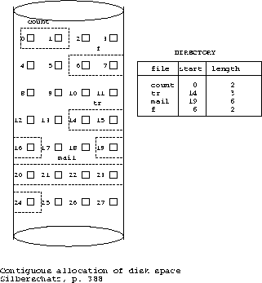

b) Linked allocation

* each data block contains the block address of the next block in the file
* each directory entry contains:
  + file name
  + **block address**: pointer to the first block
  + sometimes, also have a pointer to the last block (adding to the end of the file is much faster using this pointer)

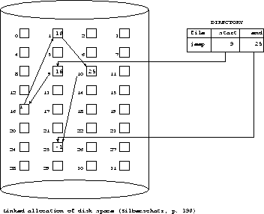

* a view of the linked list

http://www2.cs.uregina.ca/%7Ehamilton/courses/330/notes/allocate/img3.gif

c) indexed allocation

* store all pointers together in an index table
  + the index table is stored in several **index blocks**
  + assume index table has been loaded into main memory
    1. all files in one index

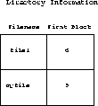

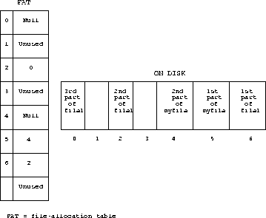

The index has one entry for each block on disk.

http://www2.cs.uregina.ca/%7Ehamilton/courses/330/notes/allocate/img6.gif

* better than linked allocation if we want to seek a particular offset of a file because many links are stored together instead of each one in a separate block
* SGG call this organization a ``linked'' scheme, but I call it an ``indexed'' scheme because an index is kept in main memory.
* problem: index is too large to fit in main memory for large disks
  + FAT may get really large and we may need to store FAT on disk, which will increase access time
  + e.g., 500 Mb disk with 1 Kb blocks = 4 bytes * 500 K = 2Mb entries

ii) separate index for each file

* index block gives pointers to data blocks which can be scattered
* direct access (computed offset)

a) one index block per file (assumes index is contiguous)

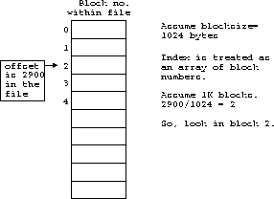

b) linked list of index blocks for each file

c) multilevel index

d) combined scheme (i-node scheme) used in UNIX